AI ASSISTED CODING
NAME: Rokalboyana Varshith
Ht No: 2403A510D7
ASSIGNMENT : 8.3
 | 1 | Task Description#1  Use AI to generate test cases for is_valid_email(email) and then implement the validator function.  Requirements:  - Must contain @ and . characters.  - Must not start or end with special characters.  - Should not allow multiple @.  Expected Output#1  - Email validation logic passing all test cases  PROMPT:  write a python function using to generate gmail Adress code  is_valid_email(email) and then implement the  validator function.  Requirements:  • Must contain @ and . characters.  • Must not start or end with special characters.  • Should not allow multiple @.  CODE:  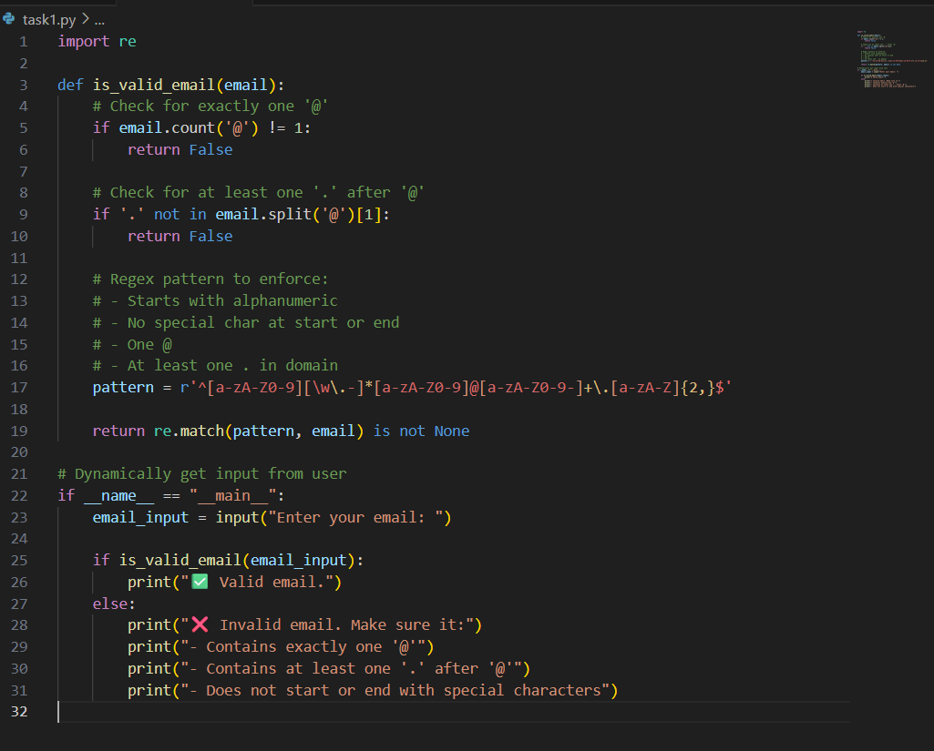  OUTPUT:  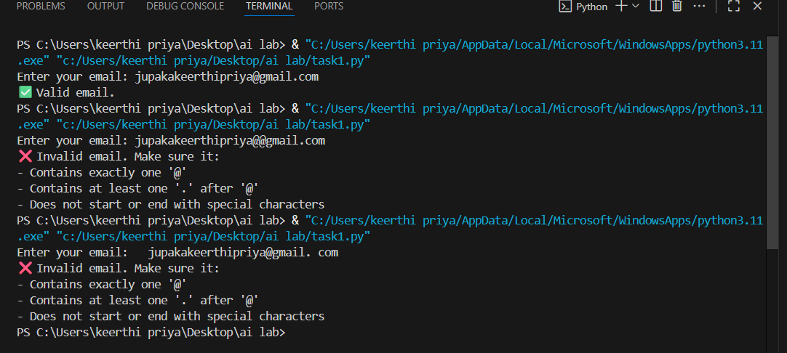  Task Description#2 (Loops)  - Ask AI to generate test cases for assign_grade(score) function. Handle boundary and invalid inputs.  Requirements  - AI should generate test cases for assign_grade(score) where: 90-100: A, 80-89: B, 70-79: C, 60-69: D, <60: F  - Include boundary values and invalid inputs (e.g., -5, 105, "eighty").  PROMT:  write a python code  for assign_grade(score) function. Handle boundary and invalid inputs.  Requirements  • AI should generate test cases for assign_grade(score) where: 90-100: A, 80-89: B, 70-79: C, 60-69: D, <60: F  • Include boundary values and invalid inputs (e.g., -5, 105, "eighty").  CODE:  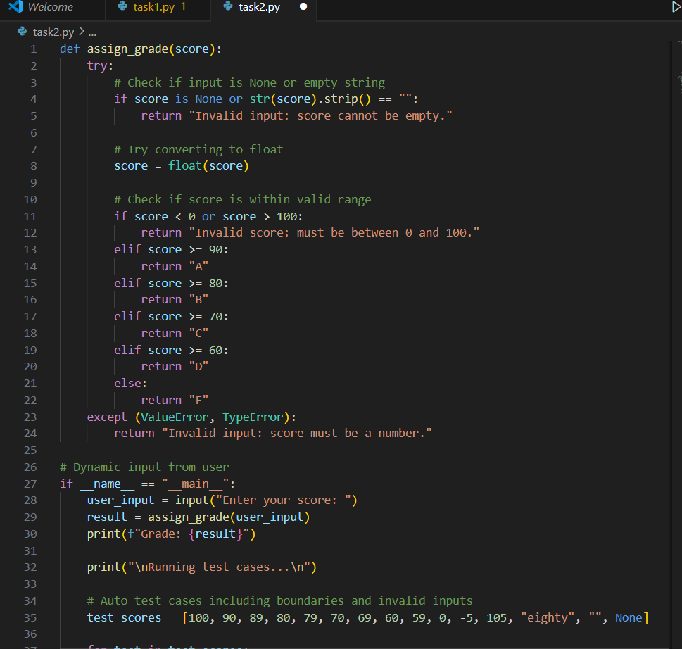  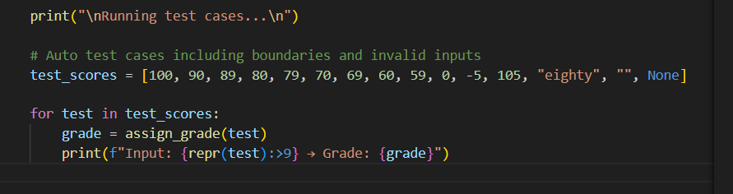  OUTPUT:  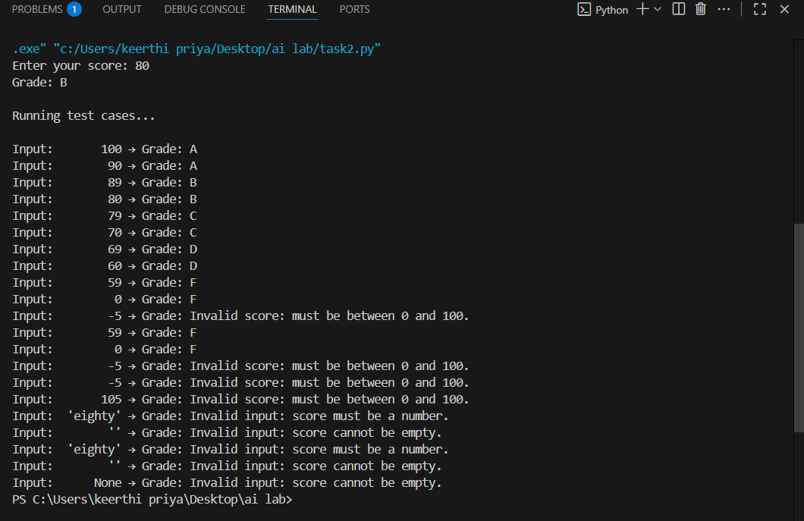  Task Description#3  - Generate test cases using AI for is_sentence_palindrome(sentence). Ignore case, punctuation, and spaces  Requirement  - Ask AI to create test cases for is_sentence_palindrome(sentence)  (ignores case, spaces, and punctuation).  - Example:  "A man a plan a canal Panama" → True  PROMPT:  Write a python code for is_sentence_palindrome(sentence). Ignore case, punctuation, and spaces  Requirement  • Ask AI to create test cases for is_sentence_palindrome(sentence)  (ignores case, spaces, and punctuation).  • Example:  "A man a plan a canal Panama" → True.  CODE:  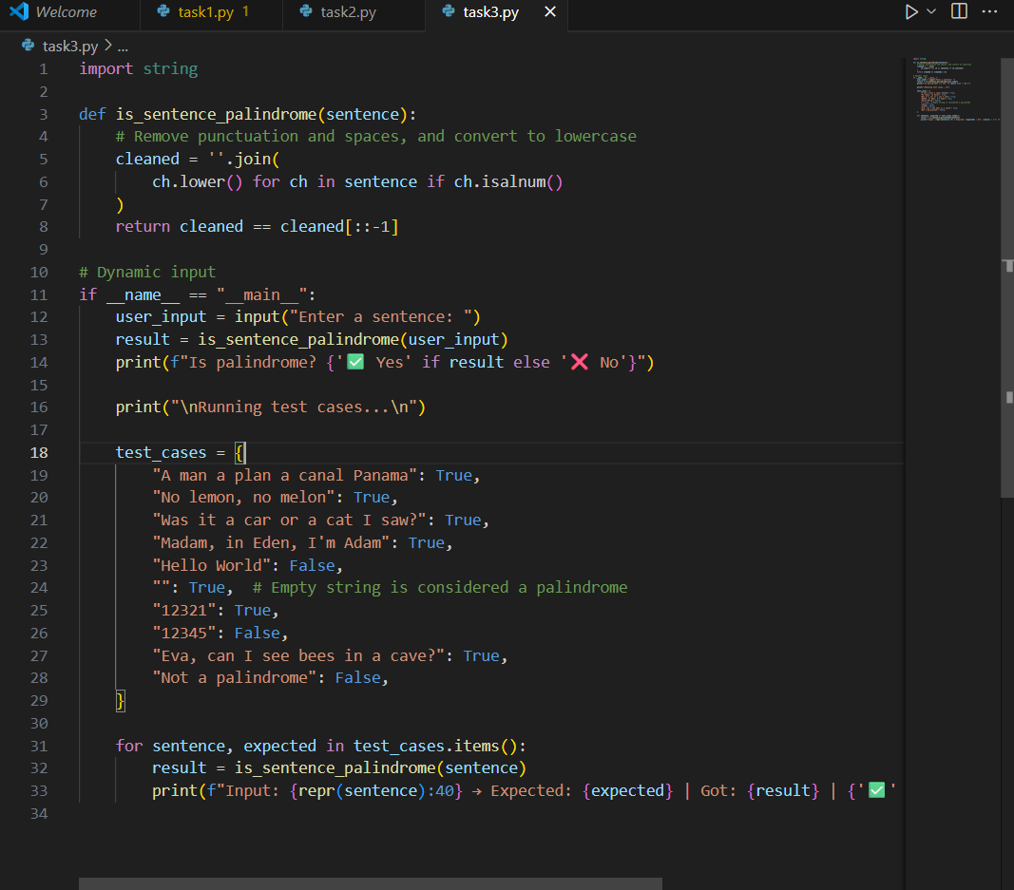  OUTPUT:  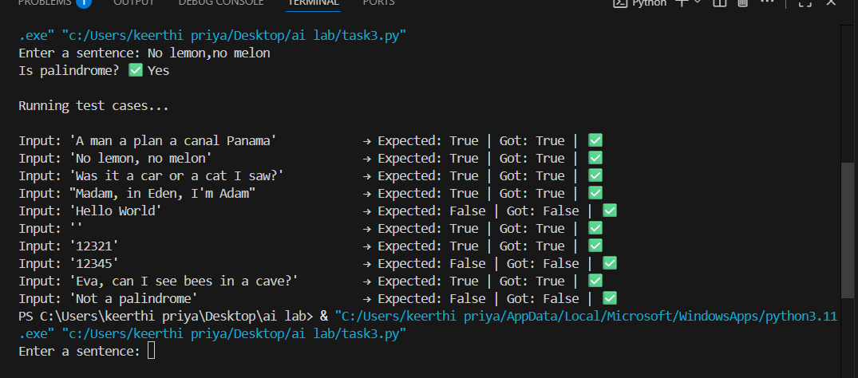  Task Description#4  - Let AI fix it Prompt AI to generate test cases for a ShoppingCart class (add_item, remove_item, total_cost).  Methods:  Add_item(name,orice)  Remove_item(name)  Total_cost()  PROMPT:  Write a python program to generate test cases for a ShoppingCart class (add_item, remove_item, total_cost).  Methods:  Add_item(name,orice)  Remove_item(name)  Total_cost() . give the code dynamically  CODE:  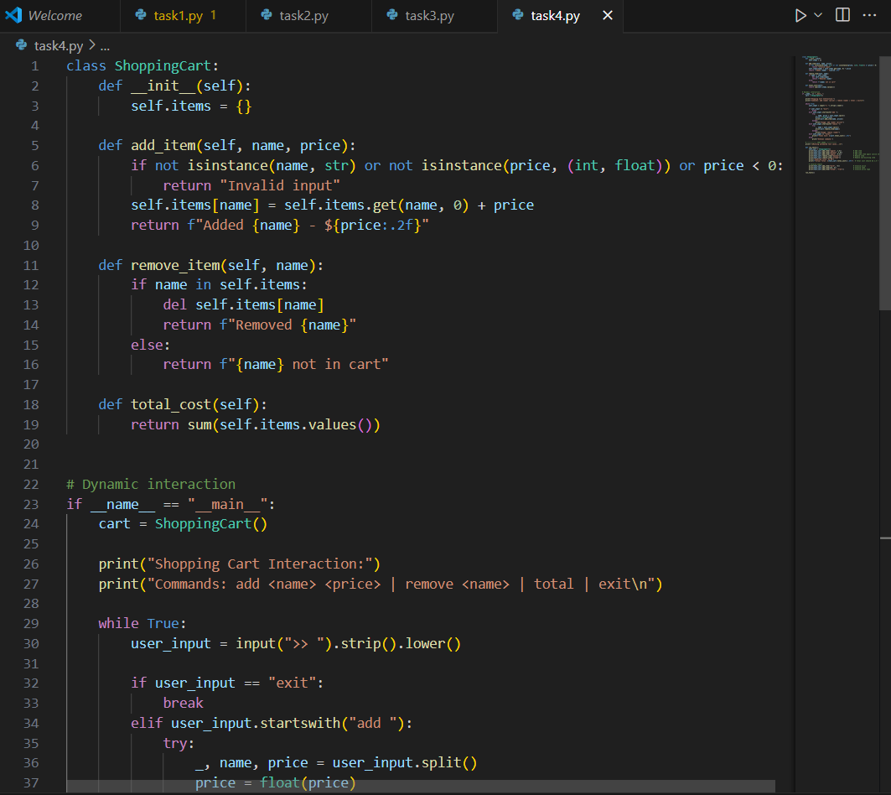  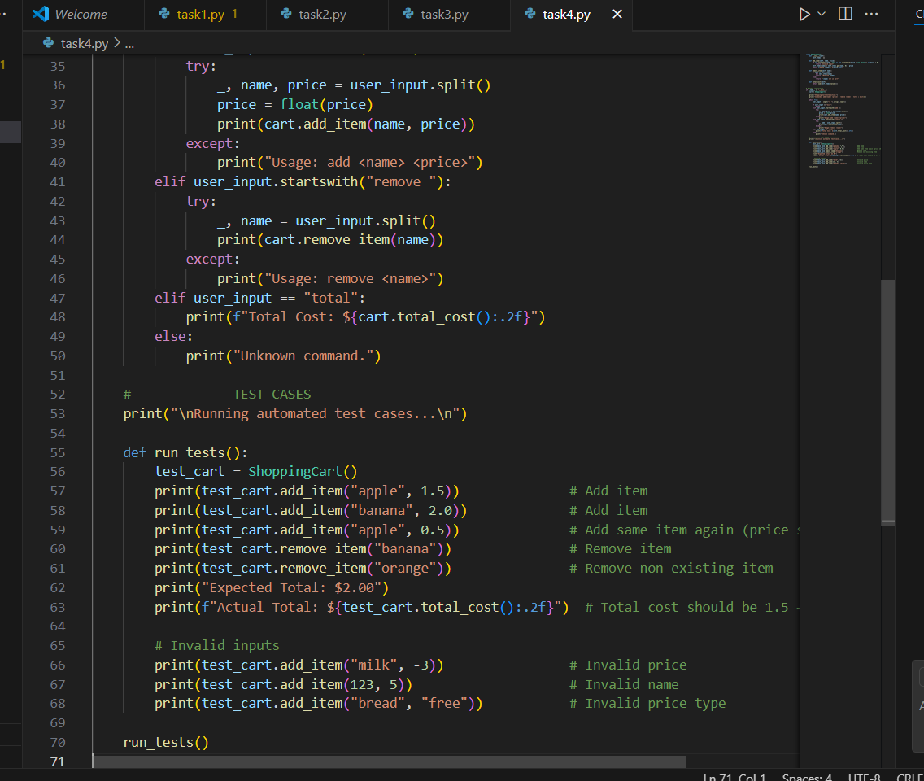  OUTPUT:  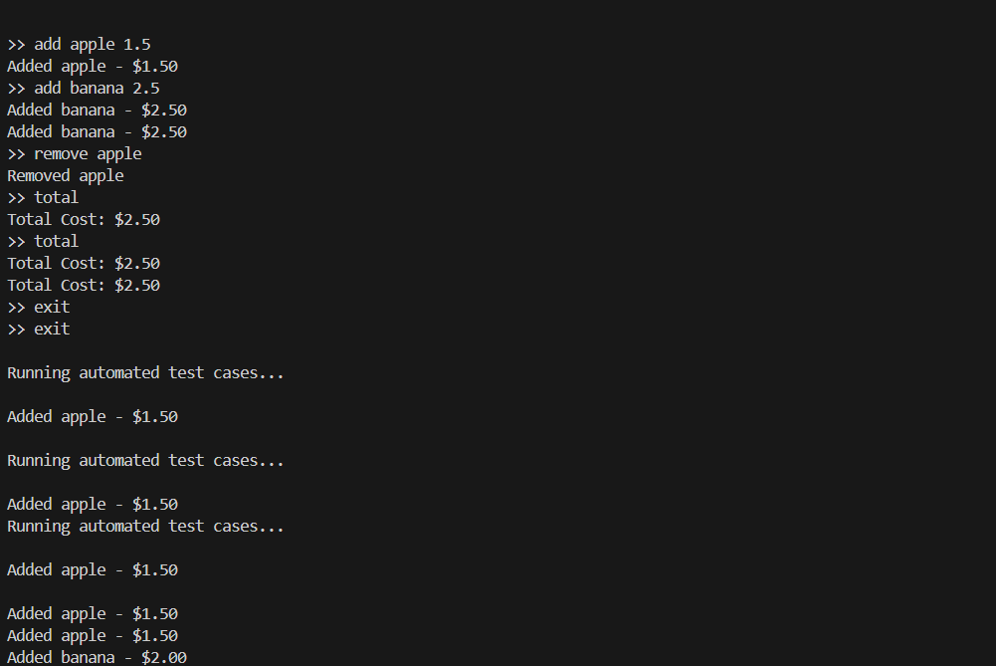  Task Description#5  - Use AI to write test cases for convert_date_format(date_str) to switch from "YYYY-MM-DD" to "DD-MM-YYYY".  Example: "2023-10-15" → "15-10-2023"  PROMPT:  Write a python program to generate convert_date_format(date_str) to switch from "YYYY-MM-DD" to "DD-MM-YYYY".  Example: "2023-10-15" → "15-10-2023". give code dynamically  CODE:  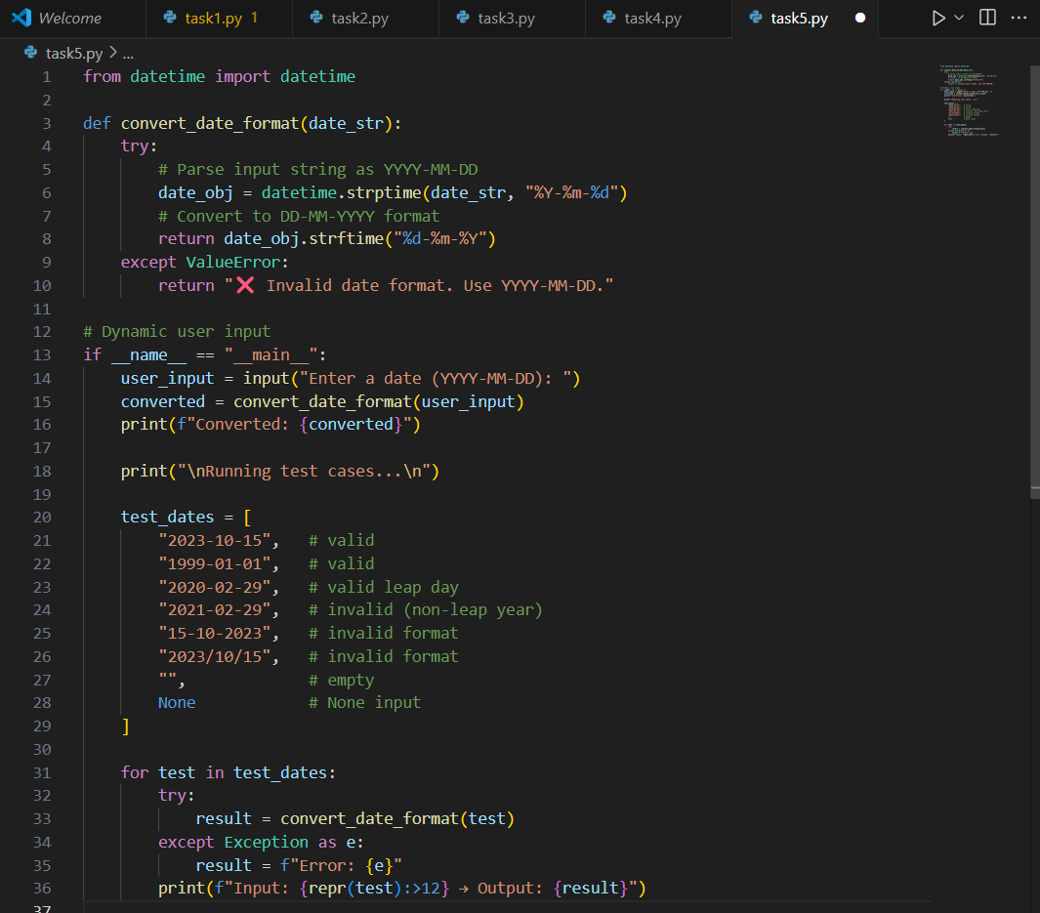  OUTPUT: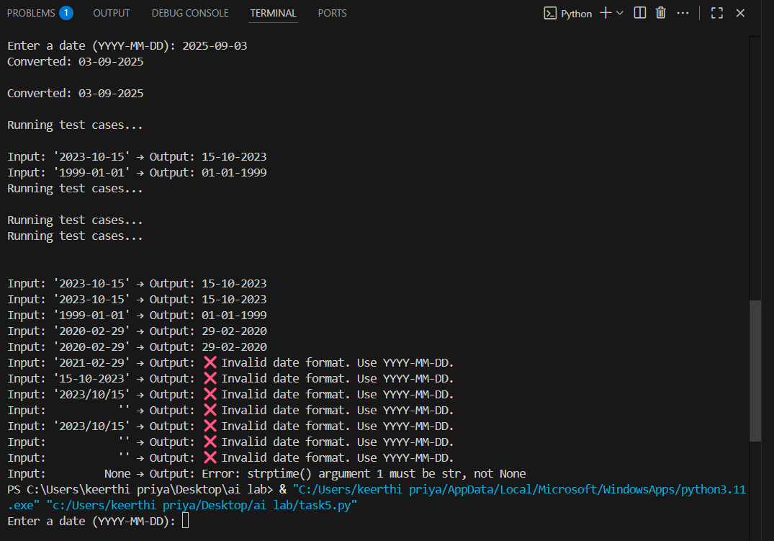  Note: Report should be submitted a word document for all tasks in a single document with prompts, comments & code explanation, and output and if required, screenshots  Evaluation Criteria:
  Criteria | Max Marks
  Task #1 | 0.5
  Task #2 | 0.5
  Task #3 | 0.5
  Task #4 | 0.5
  Task #5 | 0.5
  Total | 2.5 Marks

